Below is the LET Reviewer for Professional Education Prof. Ed.: Assessment and Evaluation of Learning Part 4.
We encourage readers/ reviewees to use the comment boxes after the article for discussion. Meanwhile, answers are already incorporated below the questions.
SEE ALSO: LET Reviewer in Prof. Ed. Assessment and Evaluation of Learning Part 1, Part 2, Part 3
1. If a test item has a difficulty index of 0.06, how would you describe the test item?
a. It is very easy.
b. It is moderately difficulty.
c. It is very difficult
d. It is difficult
2. Two sections have the same mean but the standard deviation of section 2 is higher than section 1. Which of the two sections is more homogeneous?
a. Section 1
b. Section 2
c. Both A and B
d. None of the above
3. Miss Corteza administered a test to her class and the result is positively skewed. What kind of test do you think Miss Corteza gave to her pupils?
a. Posttest
b. Pretest
c. Mastery test
d. Criterion-referenced test
4. In his second item analysis, Mr. Gonzales found out that more from the lower group got the test item 15 correctly. What does this mean?
a. The item has become more valid
b. The item has become more reliable
c. The item has a positive discriminating power
d. The item has a negative discriminating power
5. Q1 is 25th percentile as media is to what percentile?
a. 40th percentile
b. 60th percentile
c. 50th percentile
d. 75th percentile
6. Which is implied by a positively skewed scores distribution?
a. The mean, the median, and the mode are equal.
b. Most of the scores are high
c. Most of the scores are low.
d. The mode is high
7. In a normal distribution curve, what does a T-score of 60 mean?
a. Two SDs below the mean
b. Two SDs below the mean
c. One SD below the mean
d. One SD above the mean
For items 8 to 13, what does each figure/distribution on the right indicate?
8. a. mean > median > mode
b. mean < mode > median
c. mean > mode < median
d. mean < median < mode
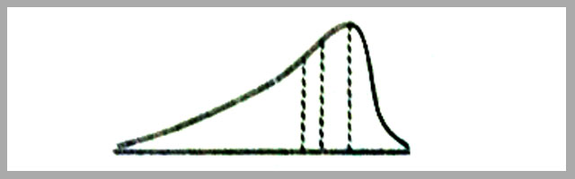
9. a. mode < mean < median
b. mode > mean > median
c. median < mode > mean
d. none of the above
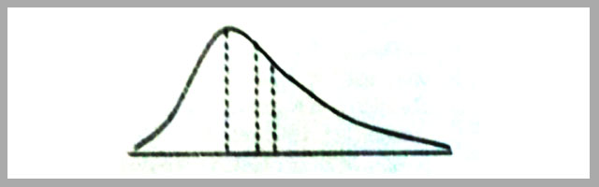
10. a. equal means, unequal standard deviations
b. equal means, equal standard deviations
c. unequal means, equal standard deviations
d. unequal means unequal standard deviations
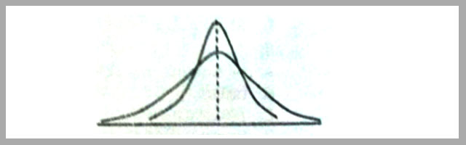
11. a unequal means, equal standard deviations
b. unequal means, equal standard deviations
c. equal means, equal standard deviations
d. equal means, unequal standard deviations
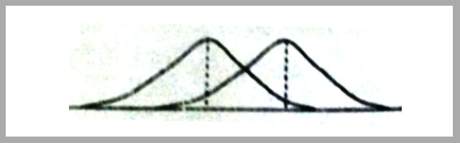
12. a. unequal variability, equal means, different shapes
b. unequal means, equal variability, different shapes
c. equal variability, equal means, different shapes
d. unequal variability, unequal means, different shapes
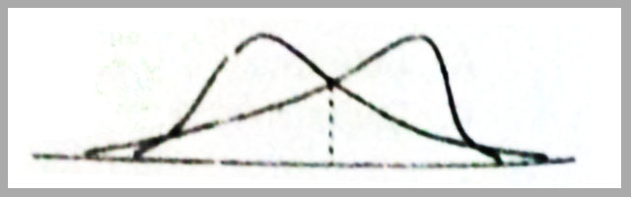
13. a. unequal means, equal standard deviations
b. equal means, unequal standard deviations
c. equal means, equal standard deviations
d. unequal means, unequal standard deviations
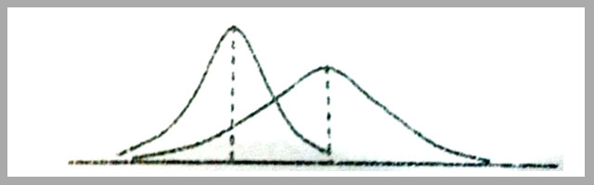
14. In conducting a parent- teacher conference, which of the following is NOT true?
a. Be friendly and informal
b. Be a know-it-all person
c. Be willing to accept suggestions
d. Be careful in giving advice
15. In a frequency distribution, what is the midpoint of the class interval whose lower and upper limits are 99.5 and 109.5?
a. 107.0
b. 105.0
c. 104.5
d. 102.5
16. In a frequency distribution, what is the interval size of the class whose lower and upper limits are 9.5 and 19.5?
a. 11.0
b. 10.0
c. 9.0
d. 5.0
17. Given a mean of 55 and a standard deviation of 8, what two scores include one standard deviation below and above the mean?
a. 46 and 63
b. 47 and 64
c. 47 and 63
d. 46 and 64
18. Given the same mean of 55 and standard deviation of 8, what score corresponds to two standard deviation above the mean?
a. 70
b. 71
c. 72
d. 73
19. What principle of test construction is violated when one places very difficult items at the beginning; thus creating frustration among students particularly those of average ability and below average?
a. All the items of particular type should be placed together in the test.
b. The items should be phrased so that the content rather than the form of the statements will determine the answer.
c. All items should be approximately 50 percent difficulty.
d. The items of any particular type should be arranged in an ascending order of difficulty.
20. Mrs. Reyes would like to find out how well her students know each other. What assessment instrument would best suit her objective?
a. Self-report instrument
b. Sociometric technique
c. Guess-who technique
d. All of the above
21. Mr. Reyes asked his pupils to indicate on the piece of paper the names of their classmates whom they would like to be with for some group activity, what assessment technique did Mr. Reyes use?
a. Self-report technique
b. Guess-who technique
c. Sociometric technique
d. Anecdotal technique
22. Which of the following assessment procedures/tools is useful in assessing social relation skills?
a. Anecdotal record
b. Attitude scale
c. Peer appraisal
d. any of the above
23. If the proportion passing for the upper and lower group is .90 and .30 respectively, what is the discrimination index?
a. .40
b. .50
c. .60
d. .70
24. Which is an example of affective learning outcome?
a. Interpret stimuli from various modalities to provide data needed in making adjustments to the environment
b. Judge problem and issues in terms of situations involved than in terms of fixed dogmatic thinking
c. Appreciate the quality and worth of the story read
d. None of the above
25. Mr. Mirasol who is a high school teacher in English conducted an item analysis of her test. She found out that four of the items of the test obtained the following difficulty and discrimination indices and as follows:
Item Number | Difficulty Index | Discrimination Index
1 | .58 | .49
2 | .92 | .72
3 | .09 | .32
4 | .93 | .15
Which of the above items should be discard in her item pool?
a. Item 1
b. Item 2
c. Item 3
d. Item 4
Answers: 1C 2A 3B 4D 5C 6C 7D 8D 9D 10A 11A 12C 13D 14B 15C 16B 17C 18B 19D 20C 21C 22C 23C 24B 25D

